Round 1 The rectangular solid part of the hole is 50 feet long, 30 feet wide, and 7 feet deep. The cube part of the hole is 30 feet long, 30 feet wide, and 7 feet deep. (Will be replaced with image)

50 feet

7 feet

30 feet

7 feet

30 feet

30 feet

Round 2. The rectangular solid part of the aquarium tank is 20 feet long, 15 feet wide, and 4 feet deep. The half-cylinder part of the tank has a radius of 7.5 feet and is 4 feet deep. (Will be replaced with image)

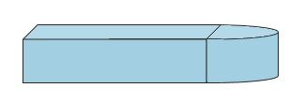

20 feet

7.5 feet

15 feet

4 feet

Round 3 f 2.6 inches, a width of 2.6 inches, and a height of 4.6 inches!



4.6 inches

2.6 inches

2 layers of 20 sodas

2.6 inches

Round 4. The mug is a cylinder with a height of 7.5 inches and a diameter of 4 inches. (Will be replaced with image)

4 inches



7.5 inches

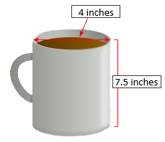

Round 5. The rectangular part of the pool is 15 yards long, 10 yards wide, and 3 yards deep. The cube part of the pool is 5 yards long, 5 yards wide, and 3 yards deep. (Will be replaced with image)

15 yards

3 yards

3 yards

10 yards

5 yards

5 yards

Round 6. You have an insulted freezer bag and are hoping to bring 48 ice cream sandwiches stacked in 3 layers with 12 sandwiches in each layer. An ice cream sandwich has a length of 6 inches, width of 2 inches, and height of 0.75 inches. What is the minimum length, width, height, and total volume you need for the insulted freezer bag?

2 inches

6 inches



0.75 inches

3 layers of 12 ice cream sandwiches

Round 7.

The rectangle part of the pond is 13 feet long, 8 feet wide, and 3.5 feet deep. The half-cylinder part of the pond has a radius of 4 feet and is 3.5 feet deep. (Will be replaced with image)

4 feet

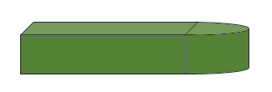

3.5 feet

8 feet

13 feet

Round 8. The planter is a half-cylinder with a height of 26 inches and an 8 inch radius.

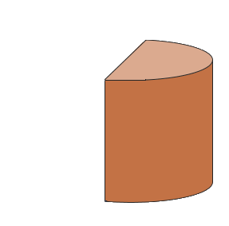

8 inches

26 inches

Round 9

2.5 inches

2 layers of 4 containers

5 inches

8.5 inches